W_gg search
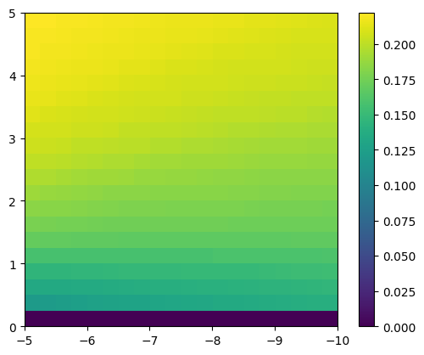
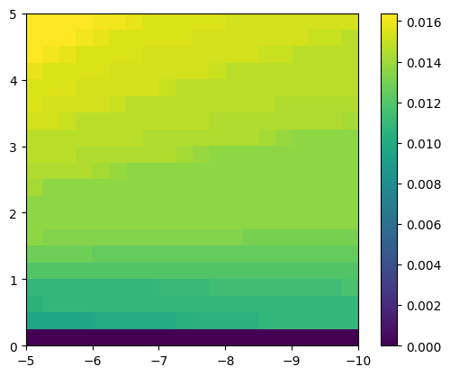
Grid only, g0 = noisy (value=2) g0 = noisy (value=4)

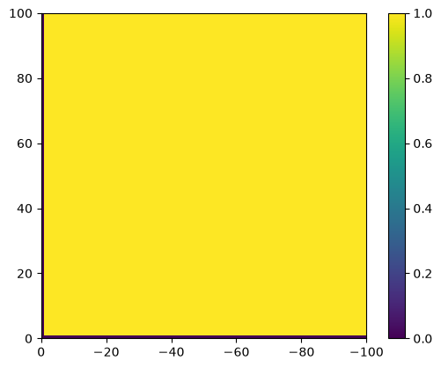
Full search, noise value = 0 noise value = 1
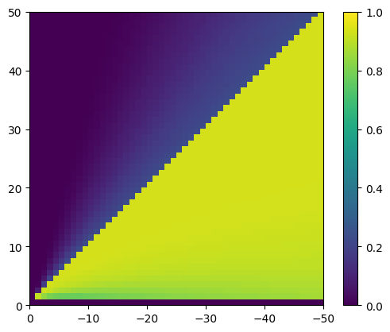

noise value = 2 noise value = 4
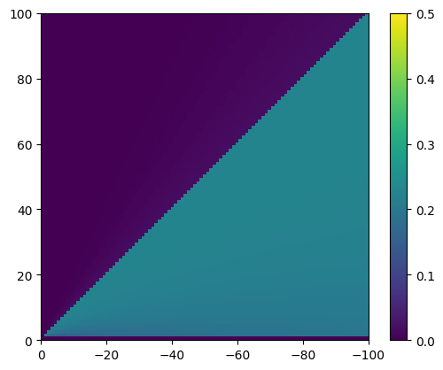
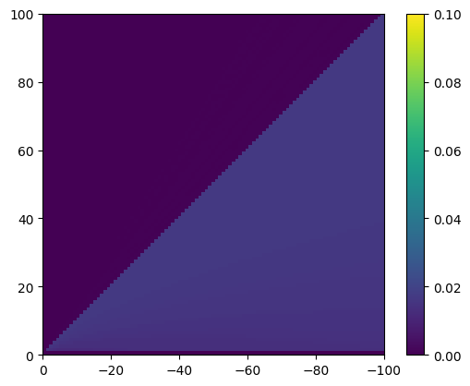

varying inh
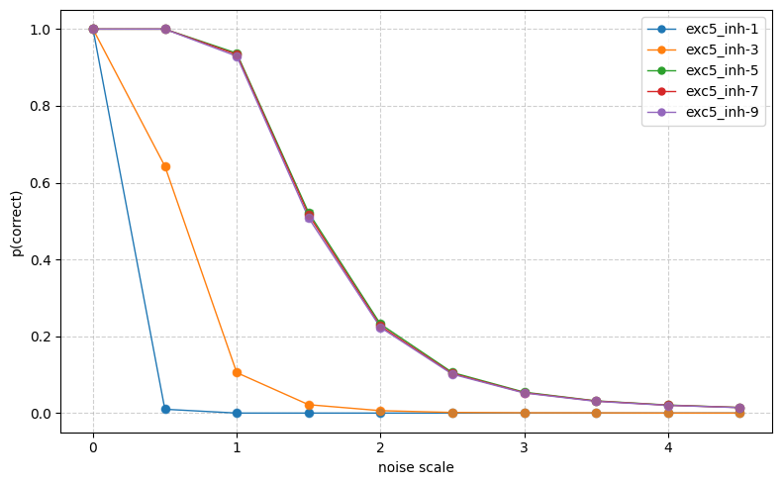
varying exc

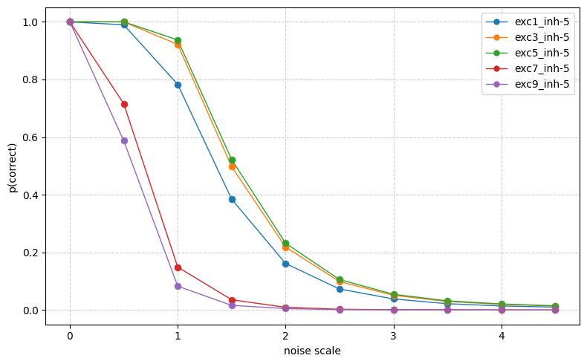

if sparsity of W_hg is 0: (sigmoid, g0, h0 = patterns)
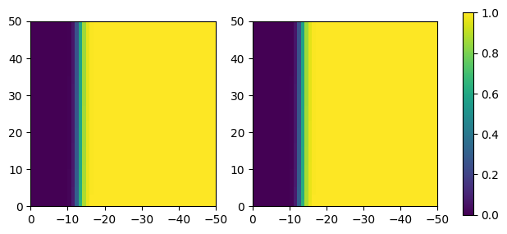

sparsity = 0.6
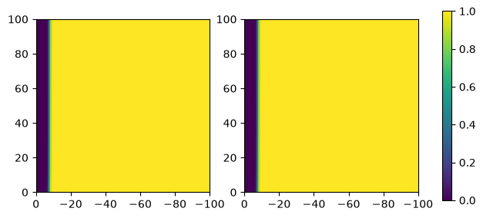

Freq, duty parameter search
W_gg = 5, -8 (around the max performance)
best parameters: freq = 0.2, duty = 0.6
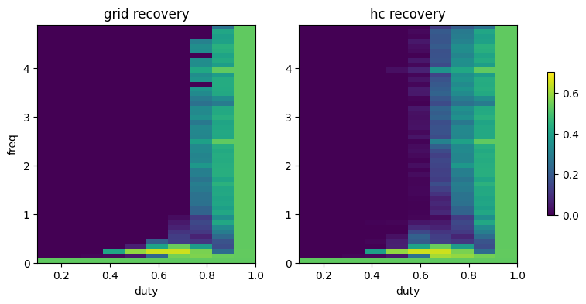

W_gg = 5, -8.75 (best performance with scaffold)
fraction correct changed from 0.458 to 0.459 – no improvement
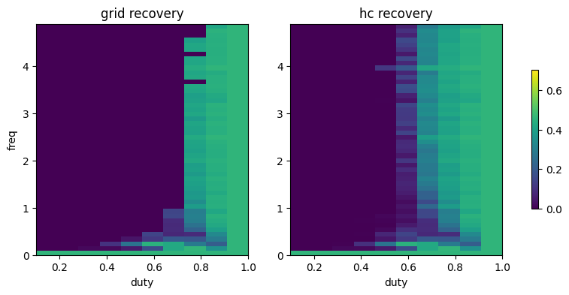

W_gg = 1, -5 (not robust to noise with grid)
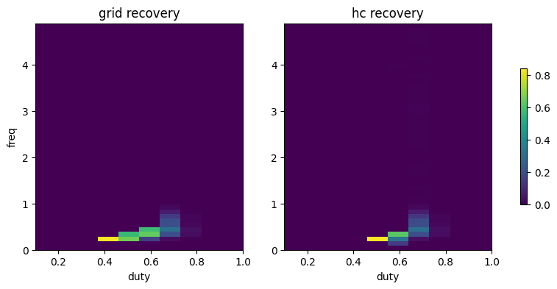
best parameters: freq=0.2, duty=0.4

